Practical - 3
Practical Title: Responsive UI Design using CSS Grid, Flexbox, and Bootstrap/Tailwind
Problem Definition 1: Design responsive layouts for Home, About, Registration, Dashboard, and Events pages using CSS Grid and Flexbox. Optional to use CSS framework such as Bootstrap or Tailwind. Ensure mobile-first responsiveness.
Theory
1: How does the layout adapt for mobile, tablet, and desktop screens?
Answer: By setting margin to auto.

2: Which layout technique is used and why?
Answer: I used heading then information layout because it is easy to approach and user friendly.

3. Are typography, spacing, colors, and contrast readable?

Answer: Yes I have set background image and text colors such that it has warmth and it does not give strain to the eye.

Implementation/ Output/Result (Keep only one option which is suitable to practical)

CSS Features & Properties Summary
The CSS styling spans internal <style> blocks and inline style="" attributes:
- Global Reset: Universal selector * resetting margin: 0, padding: 0, and box-sizing: border-box.
- Layout & Flexbox: Block level components using display: flex, flex-direction, justify-content, align-items, gap, centered alignment (margin: auto), fixed/fluid widths (px, %, vh), and absolute/relative positioning (position, z-index).
- Typography: text-align, font-size, font-weight, font-family, line-height, letter-spacing, and text-decoration.
- Styling & Effects: Card styling with border, border-radius, box-shadow, background colors (Hex, RGBA), pseudo-elements (::before), and background images (url(), background-size, opacity).
- Table Styling: border-collapse: collapse with specific cell borders and padding.
- Interactions: Pseudo-classes :hover and :focus, hover animations using transition and transform: scale(), and custom cursors (cursor: pointer).
- Responsiveness: @media (max-width: 768px) media queries used to adjust layout padding, table sizes, font sizes, and force full-width layouts (width: 100%) on mobile.

- Evidence of Work (Screenshots):
CSS SCREENSHOTS:
- 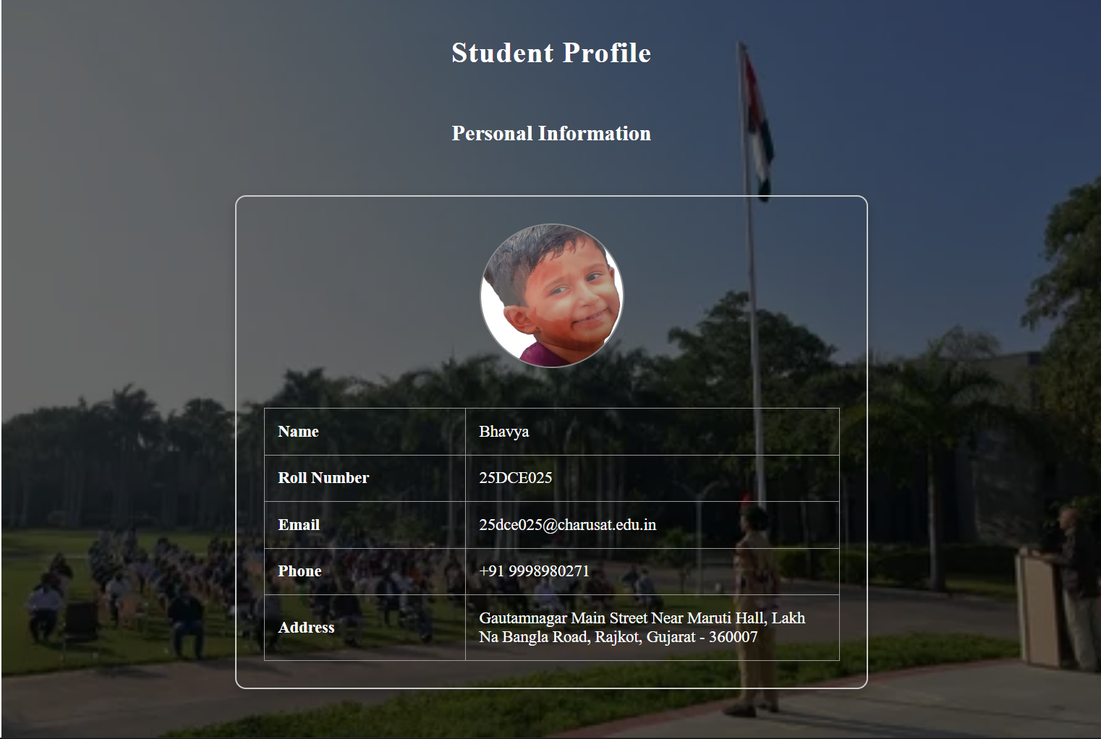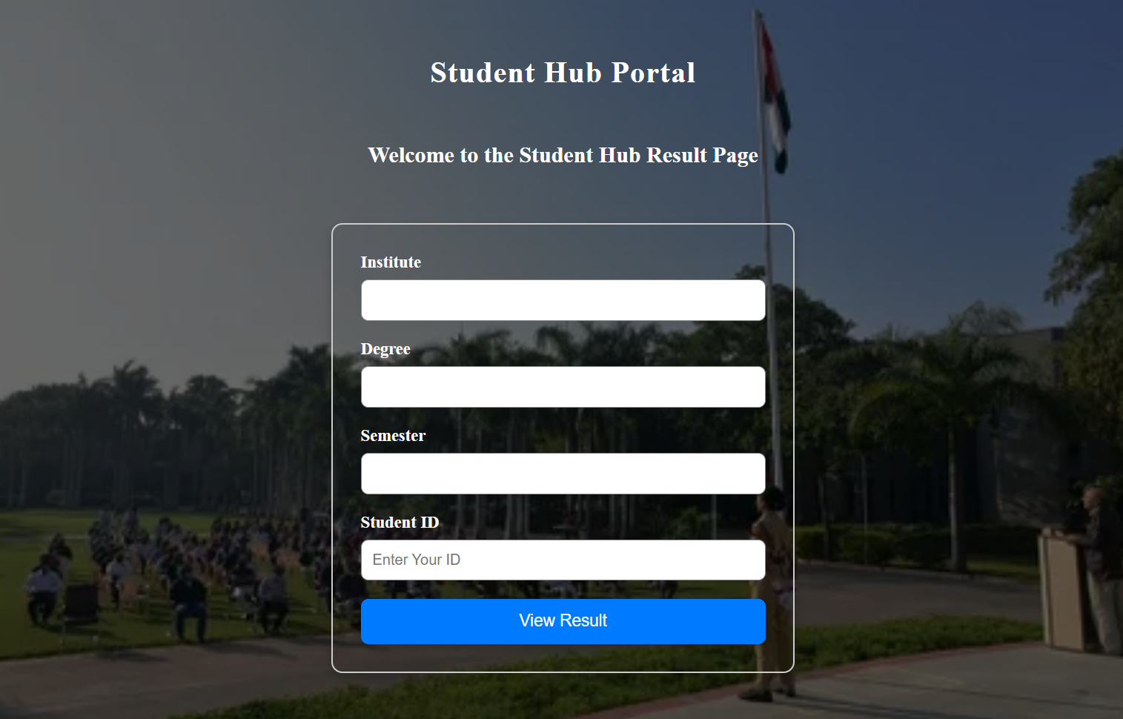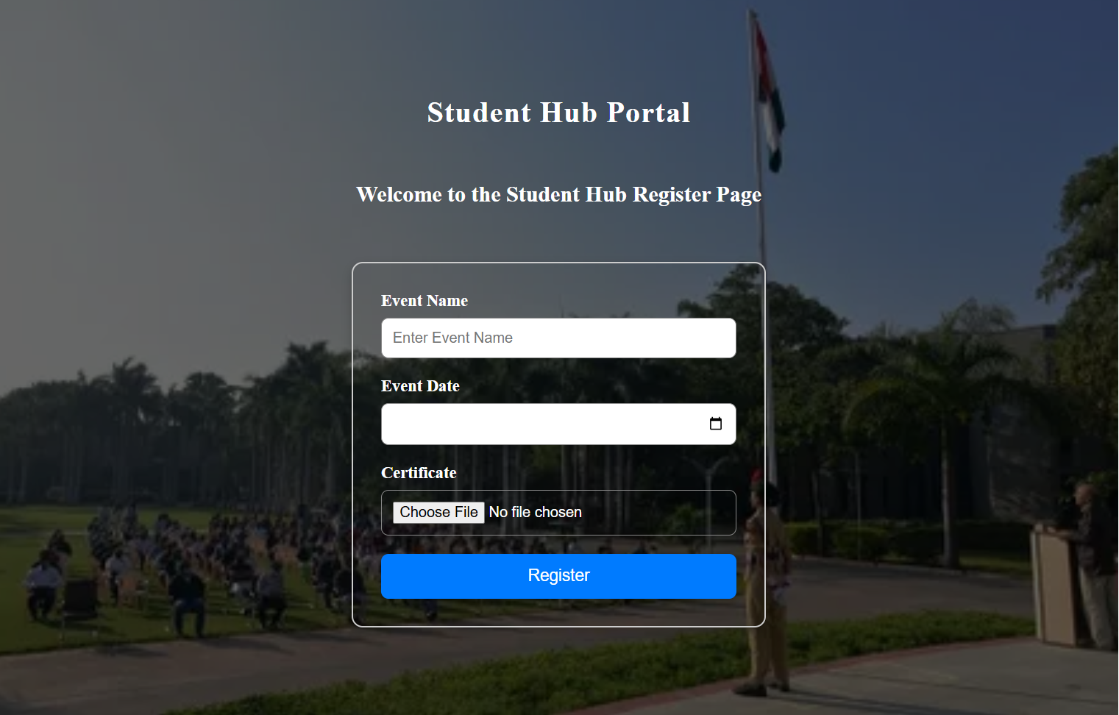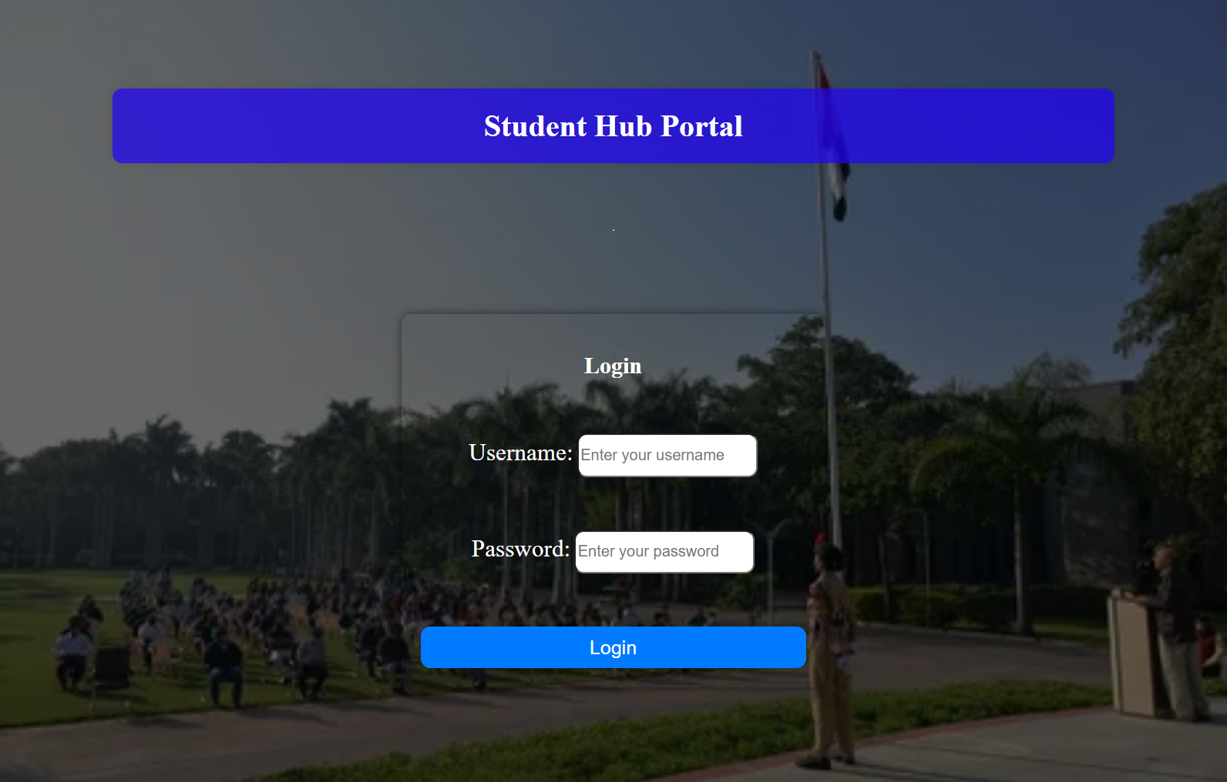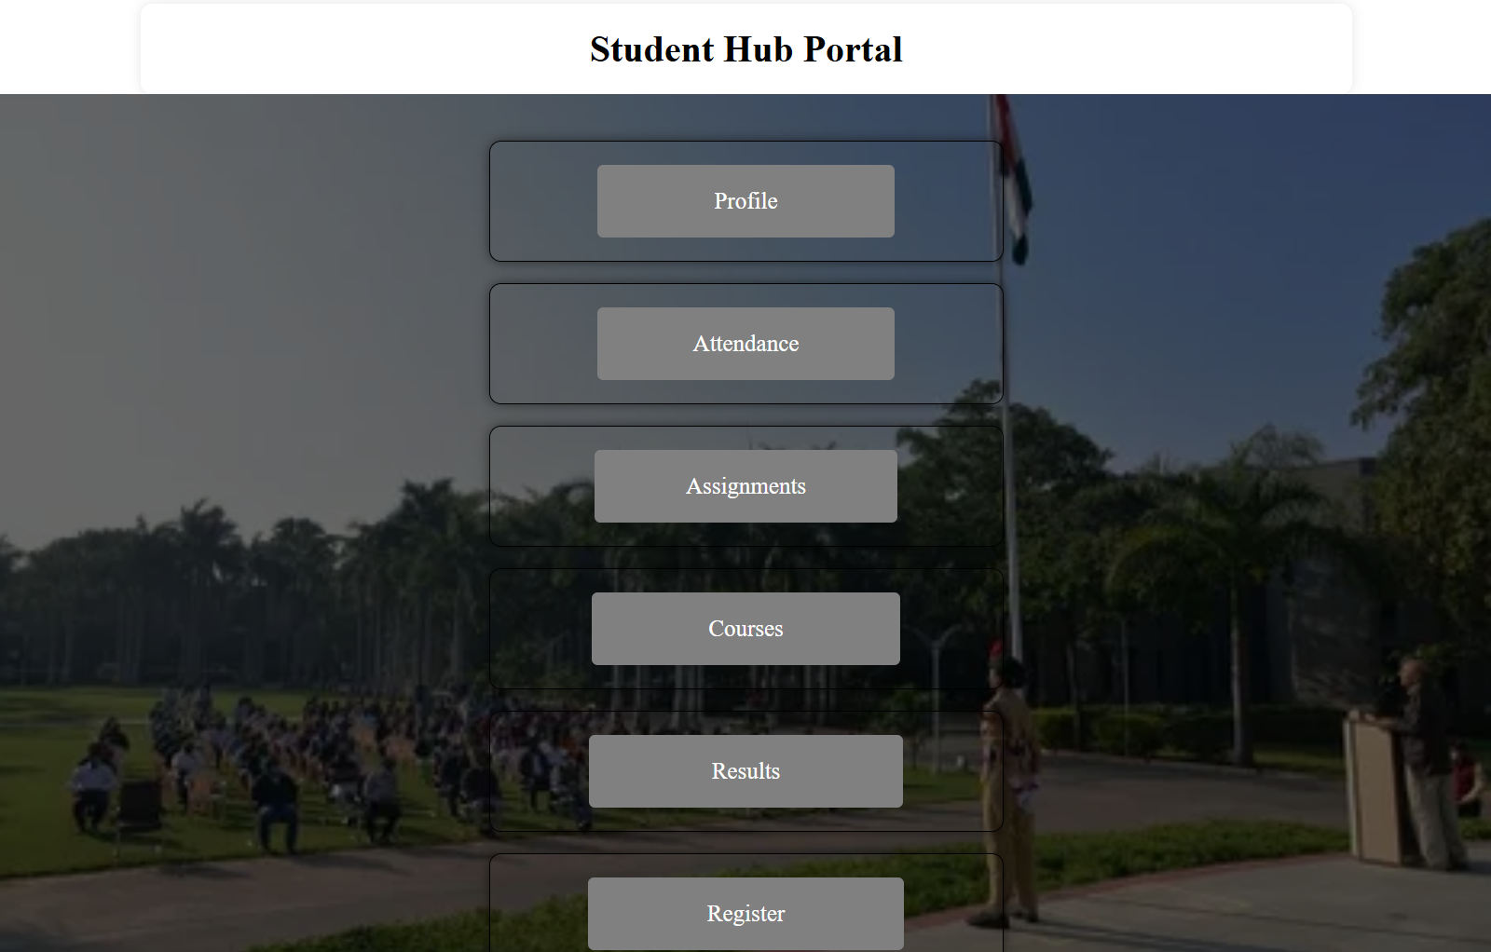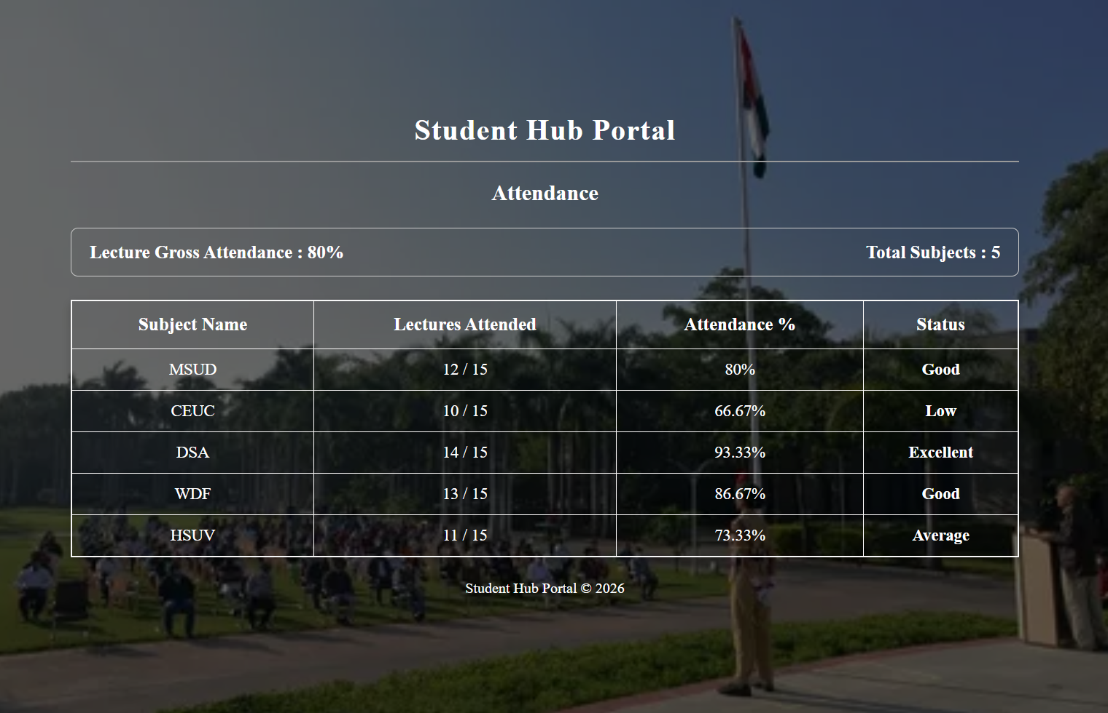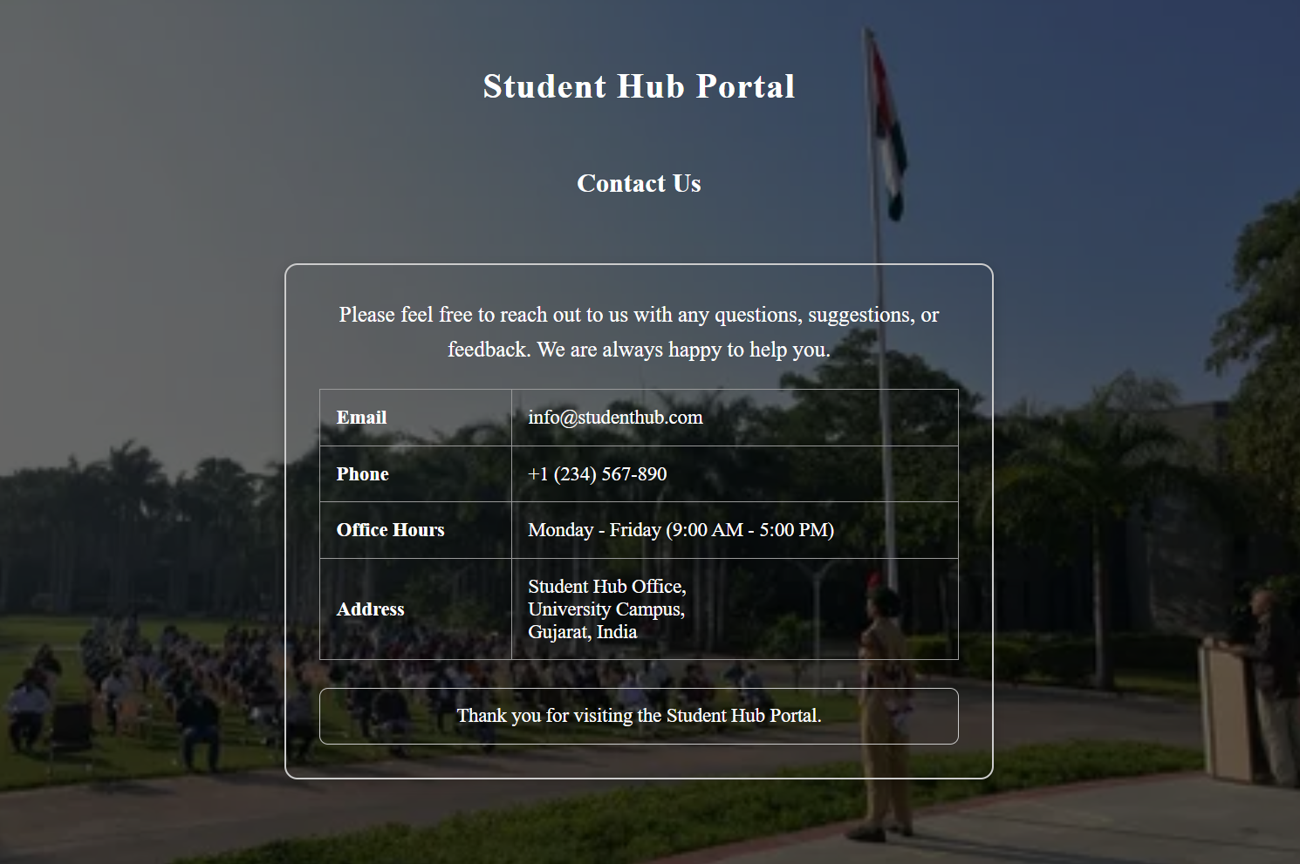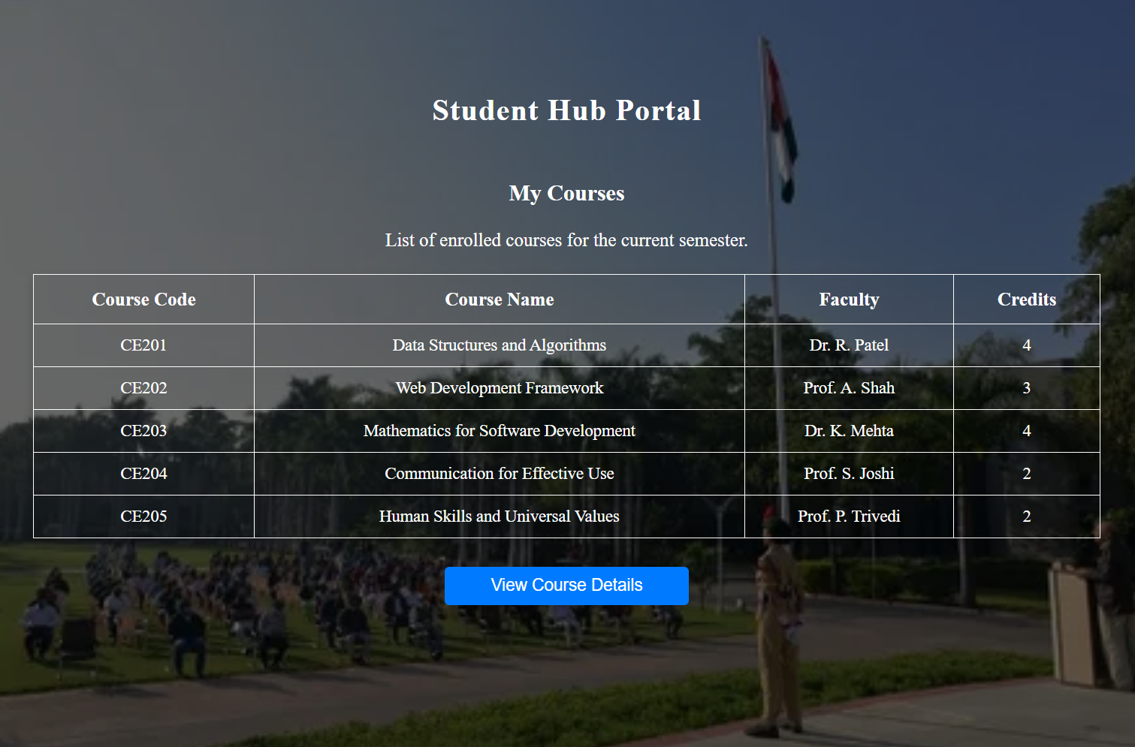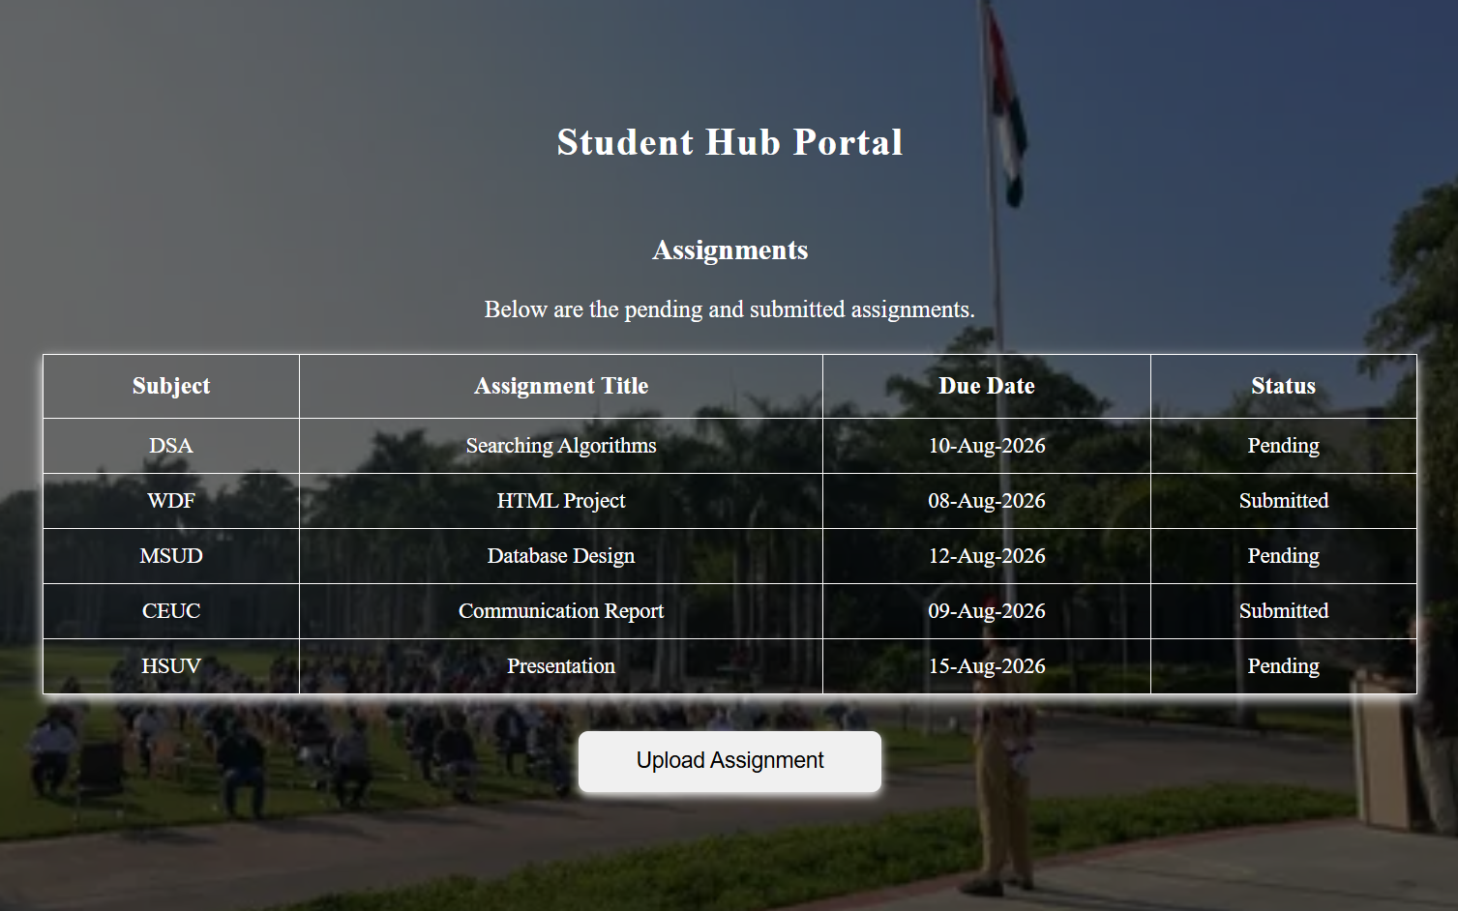
- 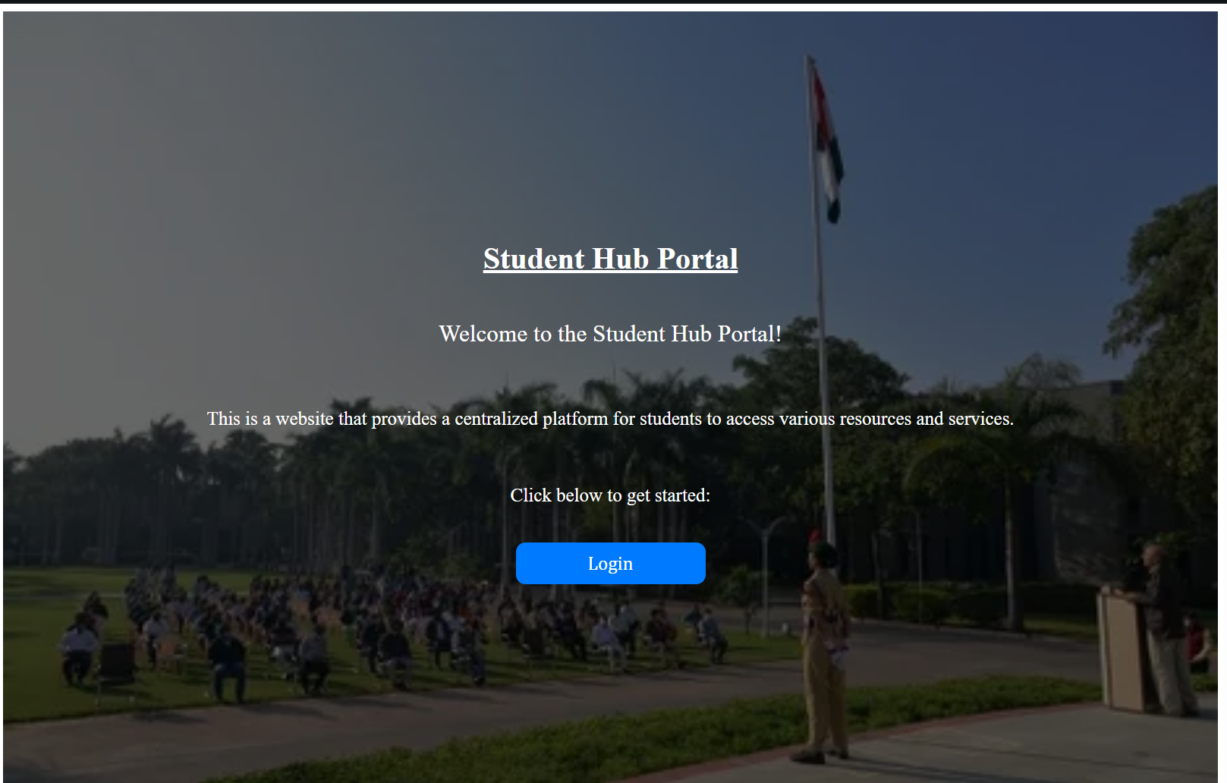

GitHub Repository Link:
https://github.com/25dce025-debug/WEB-DEVELOPMENT-WDF-

Challenges Faced:
GITHUB REPO. CREATION,FOLDER CREATION,FILE CREATION.
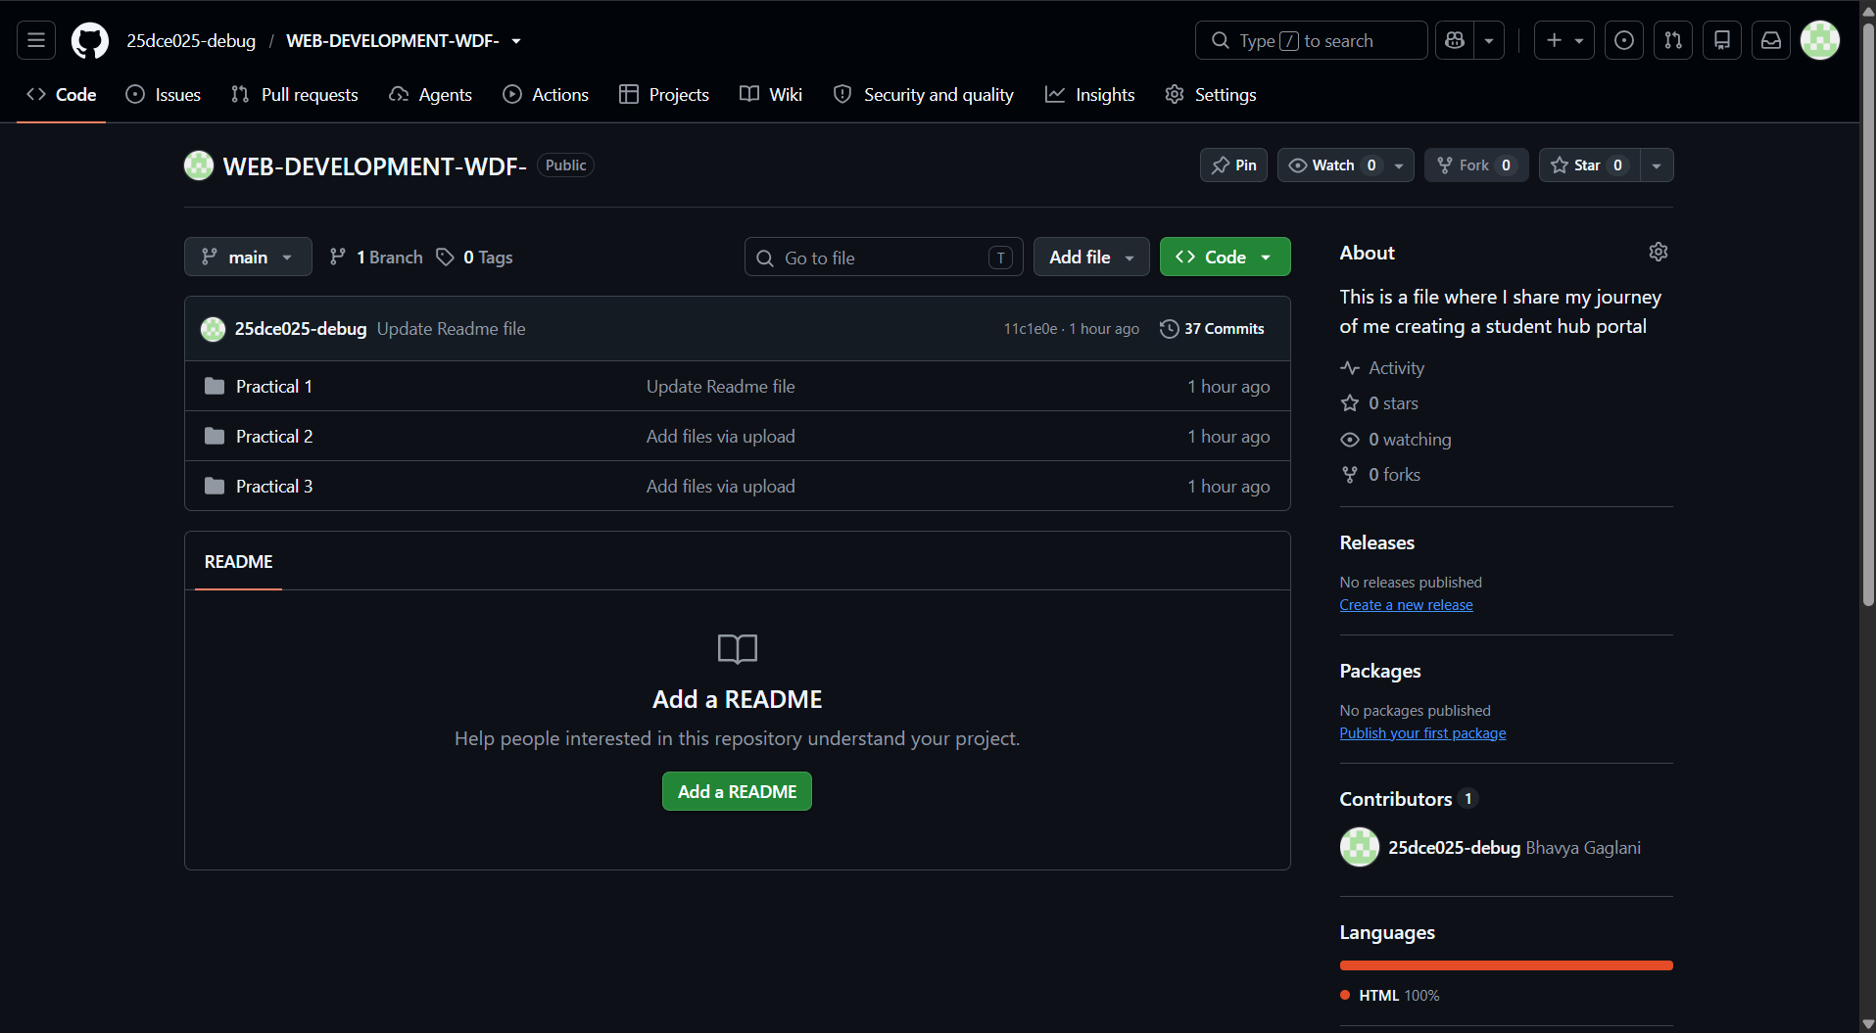
VSCODE FOLDER,FILE CREATION.
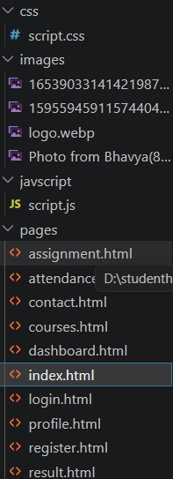
Background image setting:
It was hard to make the background image set on the website like that how it can be seen in the screenshots but with the help of autopilot and google and appropriate tags and style options in CSS I was able to nail it.

Learning Outcomes:

I LEARNED WEBSITE CREATION WITH CSS,HOW TO LINK IT EXTERNALLY,INTERNALLY,ETC.

Faculty Remarks: (Keep this blank for faculty)

